Coil Driver Hardware Description
Clayton Gumbrell
25 December 2008
Hardware Version 1

Description
The coil driver inputs are designed to require AC signals. A DC signal will only activate the device for about 1mSec. This is done to prevent software crashes from activating the driver, and thus draining the system batteries.

PCB Layout
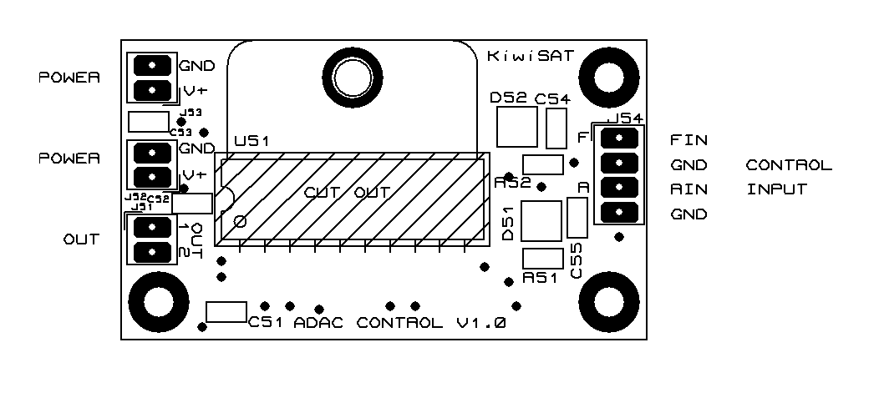

PCB Connections
J51 is the Coil connections
J52 & J53 are the Power connections
J54 is the Control connections
Connections | Signal | Description
J51 – 1 | OUT 1 | Coil Output 1
J51 – 2 | OUT 2 | Coil Output 2
J52 – 1 | V+ | V+ Supply (12V)
J52 – 2 | GND | Ground (0V) (power)
J53 – 1 | V+ | V+ Supply (12V)
J53 – 2 | GND | Ground (0V) (power)
J54 – 1 | Fin | ‘Forward’ control input.  Pulse high to power up coil ‘forwards’
J54 – 2 | GND | Ground (0V) (control signal)
J54 – 3 | Rin | ‘Reverse’ control input.  Pulse high to power up coil ‘reverse’
J54 – 4 | GND | Ground (0V)
Dual power connection are implemented to allow power to be ‘daisy-chained’ between modules.
The module has been tested with a 0.5A coil load (25R)

Operation
There are two inputs. Activate one input or the other to drive the coil in one direction or the other. Both inputs are active-high. The inputs need an AC signal to remain active. This can be a 1kHz square wave, resulting in a 50% duty cycle. However the duty cycle need not be 50% - a high signal with a low pulse every 500uSec or so will also work, keeping the driver active whenever the input is high.
Software should be written such that a system crash will stop the AC signal operating. Therefore it is probably not appropriate to just drive the signal directly from an interrupt routine – there should be some interaction from the main software loops to ensure that the coil can not remain active should the software crash.

